GULLANE ATHLETIC AFC
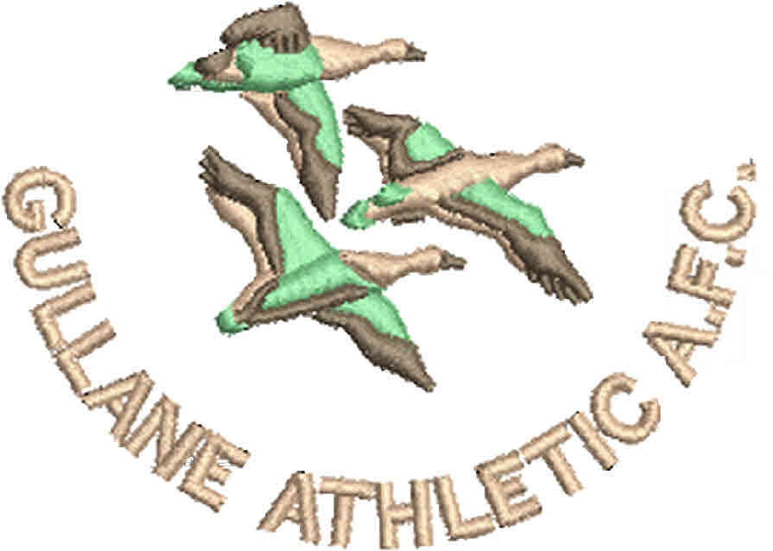
KIT ORDERING FORM 2019-2020

GAAFC play in black and white vertical stripes. Tops, shorts and socks will be available to each child who plays for a GAAFC team in a festival or match.
Kids Adults

Sizes Sizes
3-4, 5-6, 7-8, 9-11, 12-13 S, M, L, XL, XXL

Kit Available Kit Available
Hoodie with name on back £25 Hoodie with name on back £30
Hoodie without name £23 Hoodie without name £28
Kids Beanie (one size) £8 Adult Beanie (one size) £10
All items have the Gullane Athletic AFC logo embroidered on them.
Item | Size | Quantity | Name for back | Price
Hoodie with name on back *
Hoodie with name on back *
Hoodie with name on back *
Hoodie with name on back *
Hoodie with name on back *
Hoodie without name
Beanie (one size)
 |  |  | Total | £
* There are multiple rows for hoodies with the name on the back to allow for more than one purchase.
Name……………………………………………………………………………………….…..
Address…………………………………………………………………………………………
………………………………………………………………Post Code……………………….
Email Address…………………………………Telephone Number…………………………..
Age Group…………………………………
Forms should be emailed to katy@abercorncare.com or sent to Katy Hill, The Howes, Erskine Road, Gullane, EH31 2DQ.
The order will not be placed until full payment has been received either by cheque made out to GAAFC or cash. If you would like to pay by BACS please contact Katy and she will send you the details.

